**Name : Ali Azhar**

**Roll No : SU92-BSAIM-S24-026**

**Section : 3A**

**Subject : Artificial Intelligence**

**Documentation of Task 1**

**(Fizz Buzz)**

**Print Function :** In the print function i clarify all the concepts of the game for understanding of the user.

**Print() :** Print() keyword give gap to the code.

**Function (def) :** Then, i make a Function name **FizzBuzz.**

**While Loop :** Then, i use While loop for take input from the user of number. And also use condition that if User’s choice is “0” then print(“Exiting from the game…”) and then break…

**For Loop :** And then with the help of For Loop, program take range from (**1**  to **Number + 1), Number + 1** means that what the number enter by the user then loop run at **number and 1 +** in thatnumber.

**If-Else :** By condition program tell that if the number enter by user is divisible by **‘3’** the print **“Fizz”** or if divisible by **‘5’** then print “Buzz” or if is divisible by Both **‘3’ and ‘5’** then print **“FizzBuzz”** or if number is ‘0’ then print “Exiting from the game”. And in else statement i print **“Number”** whatever the number is.

**Call the Function :** At the end, i call the Function **FizzBuzz().**

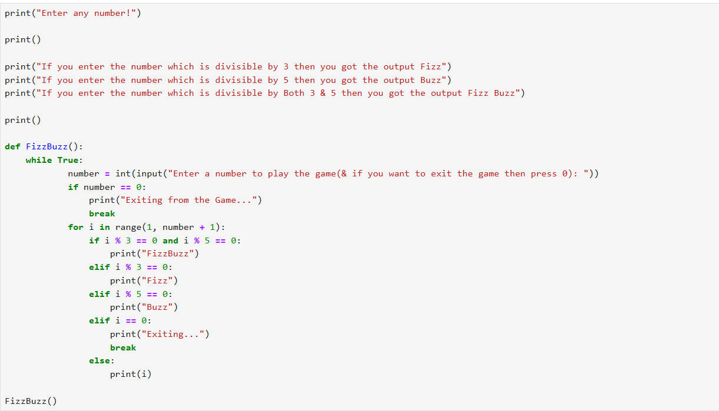

**Task 2**

**Documentation of Task 2**

**(Budget Calculate)**

**Movies List :** First of all, we take 7 movies with their names and their budget by Question and each movie is a tuple in the list.

**Function Average Budget :** In thisfunction, we calculate the average of all the budgets of movies. First of all, I declare a variable name **Total_budget = 0** than I apply for loop to check all the movies one by one and then I add the budgets of all movies (movie[1]) to the **Total_budget** variable and then apply the **formula of Average** which is **Total_budget / len(movies)** and simply I call the **Function** which is **Average** and store it in a variable named **Average_budget** and then print it.

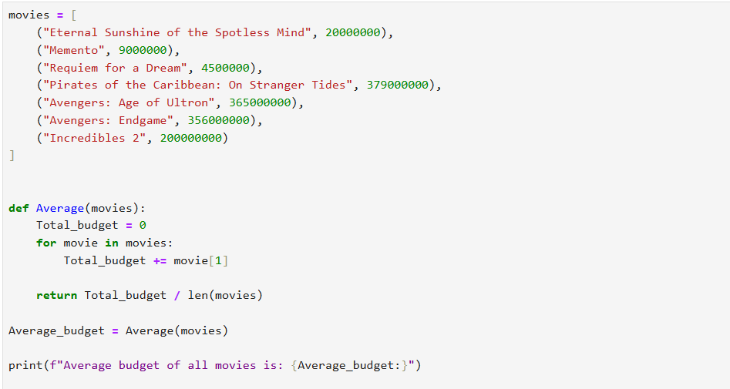

**Remaining Portion**

**Empty List :** I create an empty list named **(High_budget_movies )** and then I apply for loop to check all the movies one by one and then I apply a condition that if movie[1] (which is budgets of movies) > Average_budget then, i print **Movie name** with **their budget** which are over average means which are High_average_budget movies.

**Difference :** Then, I calculate the difference by which **High_Budget movies** are Higher than the **Average_budget_movies** and also print it with **Movie_Name** with **Movie_Budget** .

**Print :** I apply the for loop to check the High_budget_movies and then print Movie_name with Movie_budget and with Difference (movie[2]). And then simply print length of High_budget_movies.

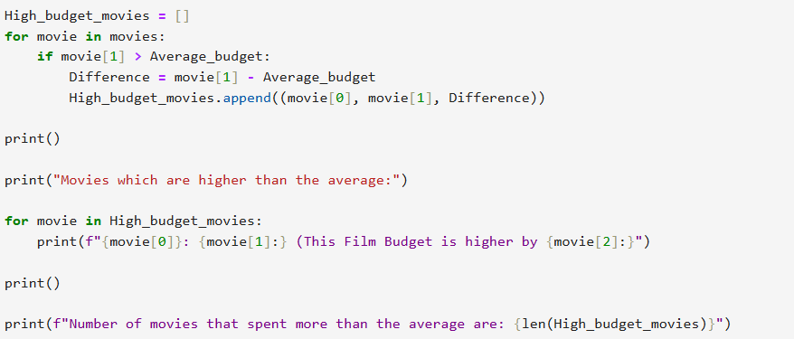

**End**